**“Does a certification take you farther than a bachelor's degree in the Technology field?”**

***CTEC 128-402***

*Ibrahima Balde*

*Micah Neal*

*Nathaniel Nelson*

**Introduction**

The field of technology is huge and endless in opportunity. Traditionally, the standard form of getting your foot into the door of this career is through seeking higher education and obtaining a bachelor's degree at an accredited university. However, due to the course of everlasting change in society, new ways of starting your career path in technology have been maneuvered and notably used. Namely being to receive accredited certifications in the specified field of technology you are trying to enter (CompTIA, Security+, etc.). The goal of this data project will be to assess the difference between certification and bachelor’s degree recipients, and whether certifications have become a more effective way to be successful in the technology industry.

Our team of data scientists will be analyzing the connection between these two options to take part in technology and whether one is more useful than the other in today's time. We will be completing this by using data from the U.S. Bureau of Labor Statistics that allows us to look at the statistics of full-time employees in technology who have just bachelor’s degrees compared to just certifications and their specific advancement levels to really determine if one is more effective than the other.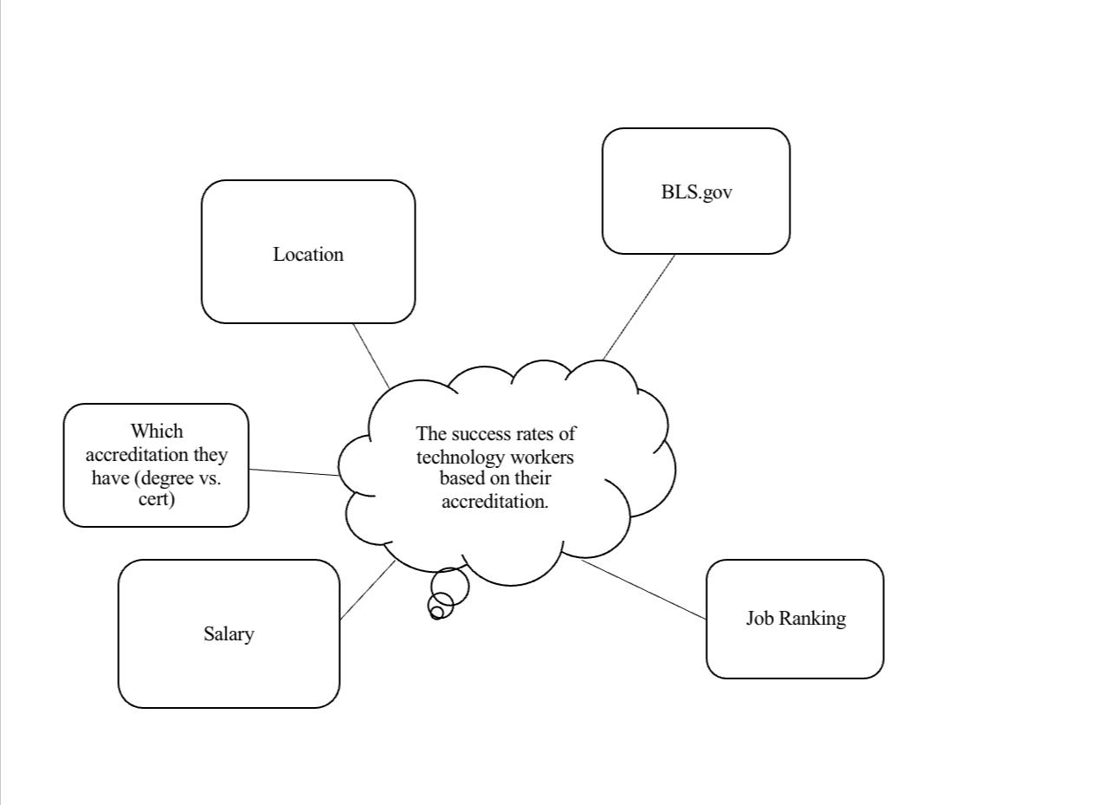

**Figure 1:** Concept Idea Map

**Project Objectives/Questions**

1. Which field of technology is the focus?
2. What is the success of the full-time workers being determined by?
3. Which job in the technology field offers the most pay?
4. What is the relationship between masters degree holders and full time-workers in technology?
5. Is there such a thing as being overqualified?

**Ingestion**

The American Community Survey (ACS) assists local politicians, community leaders, and businesses in understanding community developments. It is our country's most comprehensive source of precise demographic and housing data. The US Census Bureau annually gathers data on the demographic, social, economic, and housing features of the US population for the American Community Poll (ACS), a nationally representative survey. The ACS serves the country by offering a standardized and comprehensive set of traits that are similar across all US regions. The Public Usage Microdata Sample (PUMS) files are made accessible by the Census Bureau for use by data users who want to make bespoke tables that are not offered through summary ACS data products like the American Fact Finder. Based on ACS data gathered from 2005 through 2007, the Census Bureau published its first multiyear estimates in 2008. For geographic areas with a population of 20,000 or more, such as the entire country, all states and the District of Columbia, all congressional districts, roughly 1,800 counties, and 900 metropolitan and micropolitan statistical areas, among others, these three-year estimates of demographic, social, economic, and housing characteristics will be made available. Five-year projections will be given for regions with less than 20,000 residents. 2010 will see the release of the first 5-year estimates, which are based on ACS data gathered from 2005 through 2009. Instead of every ten years, the survey delivers updated data on all towns every year. Throughout the decade, it is distributed to a tiny fraction of the population on a rotating basis. No household will be surveyed more than once every five years. Communities may utilize this information as a valuable tool to track their changes. By completing the ACS form, individuals can guarantee that the best information is used to make choices about the future of their community. Decision-makers need a comprehensive image of their population in order to distribute limited resources in an efficient and effective manner. The American Community Survey's (ACS) Data Profiles provide the most popular social, economic, housing, and demographic data for a single geographic area. They are compiled from sources that provide both estimates and percentages to cover the most basic data on all ACS topics. Data availability varies by population size: 1-year estimates are available for regions with a population of 65,000 or more, while 5-year estimates are available for all areas. (Three-year estimates were prepared for locations with populations of 20,000 or more from 2011 to 2013). Local government officials, community leaders, and businesses may better grasp the changes occurring in their areas by using the American Community Survey (ACS). It is the best resource for comprehensive demographic and housing data about our country. For example, if you would like to see what the average income in the U.S is. You can use the American Community Survey to find that information and you can also be more specific and see that information in the area in which you reside.

**Wrangling**